Last Judgment Sunday
CHRIST LUTHERAN CHURCH | Lodi, California
November 5, 2023

WELCOME TO WORSHIP
Welcome to Christ Lutheran Church. We pray that your soul will be strengthened by the good news about God’s grace, love, and forgiveness given to us. If you would like to learn more about our church, please speak with our pastor or one of our members after the service.
- Bathrooms are located in the fellowship hall. A changing table is located in the women’s bathroom.
WORSHIP THEME
The final judgment is coming. When Jesus returns, he will bring an end to all sin, oppression, injustice, and evil. Though he sits on the judgment seat and has every right to condemn us, we will be found righteous in his sight because of the salvation he brought in his first coming; and we will live in his eternal kingdom, which will never pass away.
The season of End Time focuses us on eternal things: the eternal gospel of free and full forgiveness in Christ (Reformation Sunday); the eternal judgment that Christ will bring upon his return (Last Judgment Sunday); the eternal joys of heaven (Saints Triumphant Sunday); and Christ’s eternal reign as King of Kings (Christ the King Sunday). During this season, we will hear messages from the prophet Daniel, who saw glimpses of these eternal truths, even as he lived in exile.
The Common Service
The high and holy worship of God is faith in Jesus Christ. Such faith is created and sustained by God’s service to us (the German, “Gottesdienst,” “The Divine Service”). In the Divine Service, the Lord comes to us in His Word and Sacrament to bless and enliven us with His gifts. The Service is not something we do for God, but His service to us received in faith. The liturgy is God’s work. He gives, we receive.
HYMN Lo! He Comes With Clouds Descending | CW’21 487

INVOCATION
M: The grace of our Lord, Jesus Christ, and the love of God, and the fellowship of the Holy Spirit be with you.
C: And also with you.
CONFESSION
We confess our sins with the words of Daniel chapter 9 and in the spirit of the Reformation: we plead God’s grace alone, we allow Scripture alone to bind our consciences and lead us into truth, and we trust that by faith in Christ’s righteousness alone we stand justified before God.
M: Beloved in the Lord: let us draw near with a true heart and confess our sins to God our Father, for he is merciful and forgiving, even though we have rebelled against him. Let us seek the favor of the Lord our God by turning from our sins and giving attention to his truth:
C: Holy and merciful Father, we confess that we are by nature sinful. You are righteous, and we are covered with shame. We have not obeyed you or kept the laws you have given through your servants. We have sinned and done wrong. Please turn away your anger and wrath. We do not make requests of you because we are righteous, but because of your great mercy.

absolution
M: Lord, look with favor on your people and hear the prayers and petitions of your servants. Give ear and hear; open your eyes and see the desolation of our sins and the grieving of our spirits.
God, our heavenly Father, has been merciful to us. He has listened to our cries for mercy and acted: for his own sake, he sent his Son to bear our shame and clothe us with his righteousness. Therefore, as a called servant of Christ and by his authority, I forgive you all your sins in the name of the Father and of the Son ✙ and of the Holy Spirit.
C: Amen
M: In the peace of forgiveness, let us praise the Lord.

C: ♫ Oh, taste and see that the Lord is good. Blessed are they who take refuge in him. Your Word, O Lord, is eternal; it stands firm in the heavens. Your faithfulness continues forever. Oh, taste and see that the Lord is good. Blessed are they who take refuge in him.
PRAYER OF THE DAY
M: The Lord be with you.
C: And also with you.
M: Let us pray.
Lord God Almighty, so rule and govern our hearts and minds by your Holy Spirit that we may always look forward to the end of this present evil age and to the day of your righteous judgment. Keep us steadfast in true and living faith and present us at last holy and blameless before you; through your Son, Jesus Christ our Lord, who lives and reigns with you and the Holy Spirit, one God, now and forever.
C: Amen
FIRST LESSON Daniel 7:9–14
Daniel was confused and abhorred by his vision of four beasts. God reminds him who sits enthroned over all the nations.
⁹ “As I looked,
“thrones were set in place,
and the Ancient of Days took his seat.
His clothing was as white as snow;
the hair of his head was white like wool.
His throne was flaming with fire,
and its wheels were all ablaze.
¹⁰ A river of fire was flowing,
coming out from before him.
Thousands upon thousands attended him;
ten thousand times ten thousand stood before him.
The court was seated,
and the books were opened.

¹¹ “Then I continued to watch because of the boastful words the horn was speaking. I kept looking until the beast was slain and its body destroyed and thrown into the blazing fire. ¹² (The other beasts had been stripped of their authority, but were allowed to live for a period of time.)
¹³ “In my vision at night I looked, and there before me was one like a son of man, coming with the clouds of heaven. He approached the Ancient of Days and was led into his presence. ¹⁴ He was given authority, glory and sovereign power; all nations and peoples of every language worshiped him. His dominion is an everlasting dominion that will not pass away, and his kingdom is one that will never be destroyed.
PSALM Psalm 90 page 99
SECOND LESSON 1 Thessalonians 5:1–11
Paul encourages us to keep watch over our lives as we await the Day of Christ’s return.
5 Now, brothers and sisters, about times and dates we do not need to write to you, ² for you know very well that the day of the Lord will come like a thief in the night. ³ While people are saying, “Peace and safety,” destruction will come on them suddenly, as labor pains on a pregnant woman, and they will not escape.
⁴ But you, brothers and sisters, are not in darkness so that this day should surprise you like a thief. ⁵ You are all children of the light and children of the day. We do not belong to the night or to the darkness. ⁶ So then, let us not be like others, who are asleep, but let us be awake and sober. ⁷ For those who sleep, sleep at night, and those who get drunk, get drunk at night. ⁸ But since we belong to the day, let us be sober, putting on faith and love as a breastplate, and the hope of salvation as a helmet. ⁹ For God did not appoint us to suffer wrath but to receive salvation through our Lord Jesus Christ. ¹⁰ He died for us so that, whether we are awake or asleep, we may live together with him. ¹¹ Therefore encourage one another and build each other up, just as in fact you are doing.

VERSE OF THE DAY Matthew 24:42
Alleluia. Watch therefore, for you do not know on what day your Lord is coming. Alleluia.

THE GOSPEL Matthew 25:31–46
When Jesus returns, he will separate all people into two groups. We remember that our righteousness in God’s sight is based on the good works he credits to our account, and not based on our own merits.
³¹ “When the Son of Man comes in his glory, and all the angels with him, he will sit on his glorious throne. ³² All the nations will be gathered before him, and he will separate the people one from another as a shepherd separates the sheep from the goats. ³³ He will put the sheep on his right and the goats on his left.
³⁴ “Then the King will say to those on his right, ‘Come, you who are blessed by my Father; take your inheritance, the kingdom prepared for you since the creation of the world. ³⁵ For I was hungry and you gave me something to eat, I was thirsty and you gave me something to drink, I was a stranger and you invited me in, ³⁶ I needed clothes and you clothed me, I was sick and you looked after me, I was in prison and you came to visit me.’
³⁷ “Then the righteous will answer him, ‘Lord, when did we see you hungry and feed you, or thirsty and give you something to drink? ³⁸ When did we see you a stranger and invite you in, or needing clothes and clothe you? ³⁹ When did we see you sick or in prison and go to visit you?’
⁴⁰ “The King will reply, ‘Truly I tell you, whatever you did for one of the least of these brothers and sisters of mine, you did for me.’
⁴¹ “Then he will say to those on his left, ‘Depart from me, you who are cursed, into the eternal fire prepared for the devil and his angels. ⁴² For I was hungry and you gave me nothing to eat, I was thirsty and you gave me nothing to drink, ⁴³ I was a stranger and you did not invite me in, I needed clothes and you did not clothe me, I was sick and in prison and you did not look after me.’
⁴⁴ “They also will answer, ‘Lord, when did we see you hungry or thirsty or a stranger or needing clothes or sick or in prison, and did not help you?’
⁴⁵ “He will reply, ‘Truly I tell you, whatever you did not do for one of the least of these, you did not do for me.’
⁴⁶ “Then they will go away to eternal punishment, but the righteous to eternal life.”

M This is the Gospel of the Lord.
C: Praise be to you, O Christ!
HYMN OF THE DAY Day of Wrath, Oh, Day of Mourning| CW 209

SERMON Daniel 7

APOSTLES’ CREED
I believe in God, the Father Almighty,
maker of heaven and earth.
I believe in Jesus Christ, his only Son, our Lord,
who was conceived by the Holy Spirit,
born of the Virgin Mary,
suffered under Pontius Pilate,
was crucified, died, and was buried.
He descended into hell.
The third day he rose again from the dead.
He ascended into heaven
and is seated at the right hand of God the Father Almighty.
From there he will come to judge the living and the dead.
I believe in the Holy Spirit,
the holy Christian Church,
the communion of saints,
the forgiveness of sins,
the resurrection of the body,
and the life everlasting. Amen.

OFFERING
In response to God’s love and forgiveness, we give back a portion of what he has given us. The members of Christ Lutheran Church have joined to proclaim the gospel to this community. These offerings support that work. While our guests are welcome to participate, they should not feel obligated to do so.

PRAYER OF THE CHURCH
P: Lord Jesus, King of kings and Lord of the nations,
All creation waits in eager expectation for the children of God to be revealed, when it will be liberated from its bondage to decay and brought into the freedom and glory of the children of God. We ourselves groan inwardly as we behold the ravages of war. On this day, we thank you for all those who have kept watch over our nation in the past and served to protect us from harm.
C: We thank you, Lord, for our military veterans.
P: Because of their time of service to our country, there are many veterans who do not live in peace. There are many who do not wish to be thanked for their service, because they are ashamed by what they have done or failed to do.
C: Move us to offer our patient, listening hearts to all who suffer.
P: Although none of us fully enjoys the perfect peace we have in you, Lord Jesus, may we wait and watch for that day when you will restore all things for us.
C: You have been our dwelling place throughout all generations. From everlasting to everlasting, you are God.
P: Although the devil and his minions continue their assault to rob people of peace in Jesus, remind us of the armor you provide to protect minds and hearts, bodies and souls.
C: May all who fight the good fight of faith “put on faith and love as a breastplate and the hope of salvation as a helmet.”
P: May your people who serve in the armed forces serve with honor. Remind them of their identity and purpose which comes only from you: through baptism, they are forgiven, loved children of their heavenly Father, bought and purchased with the blood of his Son, called and kept in the true faith by the Holy Spirit.
C: Have compassion on your servants. Satisfy us in the morning with your unfailing love that we may sing for joy and be glad all our days.
P: Hear us for Jesus’ sake as we join to pray:

LORD’S PRAYER Matthew 6:9-13; Luke 11:2-4
C: Our Father, who art in heaven,
hallowed be thy name,
thy kingdom come, thy will be done
on earth as it is in heaven.
Give us this day our daily bread;
and forgive us our trespasses,
as we forgive those who trespass against us;
and lead us not into temptation,
but deliver us from evil.
For thine is the kingdom and the power
and the glory forever and ever. Amen.
M: O Lord God, our heavenly Father, pour out the Holy Spirit on your faithful people. Keep us strong in your grace and truth, protect and comfort us in all temptation, and bestow on us your saving peace, through Jesus Christ, our Lord.
C: Amen.

THE BLESSING
M: The Lord bless you and keep you.
The Lord make his face shine on you and be gracious to you.
The Lord look on you with favor and ✙ give you peace.
C: Amen.
CLOSING HYMN The Day Full of Grace | CW 254

COPYRIGHT INFORMATION
Content requiring a copyright license is reproduced under OneLicense.net #A-718312. All rights reserved. The Common Service: Texts revised from The Lutheran Hymnal, 1941. Music revised by James Engel. Scripture Quotations: From the Holy Bible, New International Version (NIV 1984), © 1973, 1978, 1984 by Biblica, Inc.

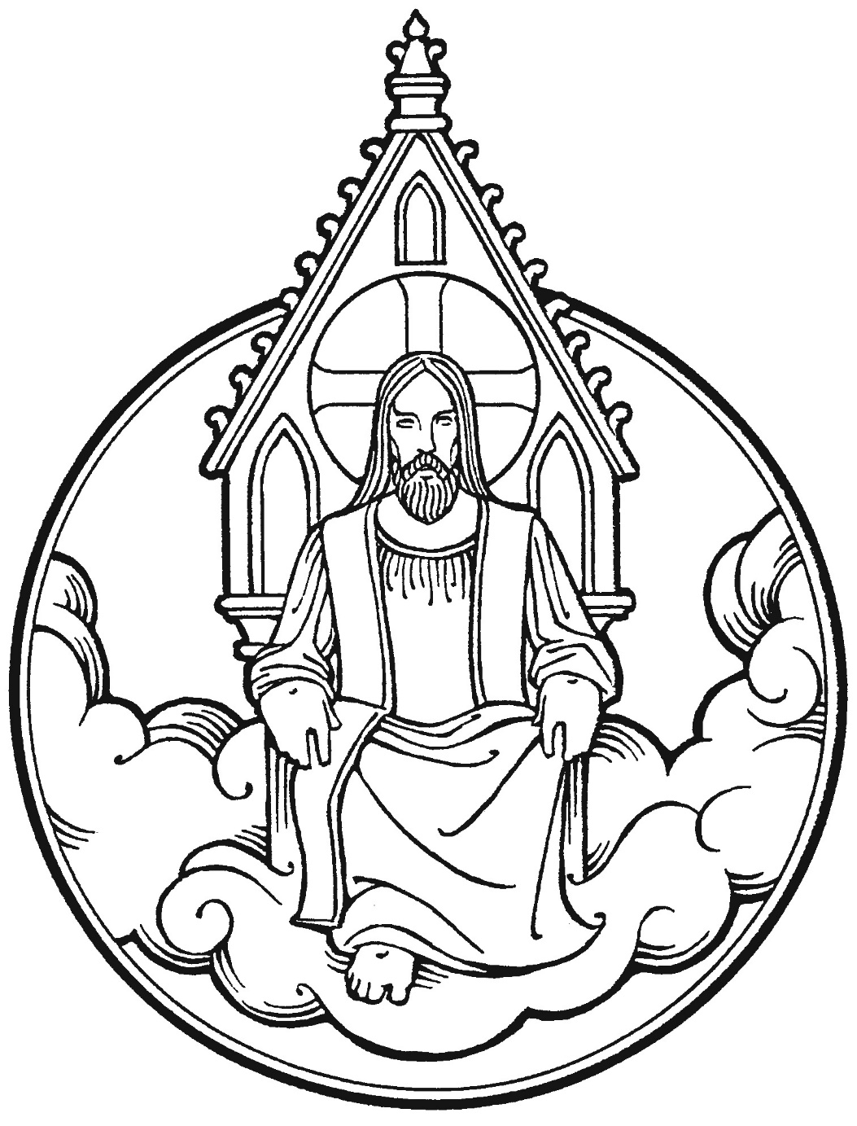

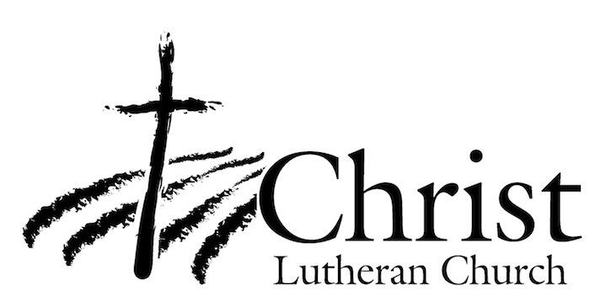
13009 N. Elderberry Ct.
Lodi, CA 95242
www.christlodi.org
209-368-6250
Pastor Timothy Leistekow
WELCOME TO CHRIST EV. LUTHERAN CHURCH!
We preach a message of forgiveness, hope and peace
through the death and resurrection of Jesus Christ.
Families and individuals of all ages will find opportunities
both to grow and to serve.
Our mission statement:
Look what Christ is doing!
He binds us together in fellowship
He gathers us in for worship
He builds us up for service
He sends us out with the gospel

“Now you are the body of Christ,
and each one of you is a part of it.”
(1 Corinthians 12:27)

